Dr. Ashish Nautiyal, D.Phil.
Assistant Professor | Department of Physics
Government Degree College, Rudraprayag, Uttarakhand – 246171
Email: ashishnautiyal05@rediffmail.com | Mobile: +91-9627519961
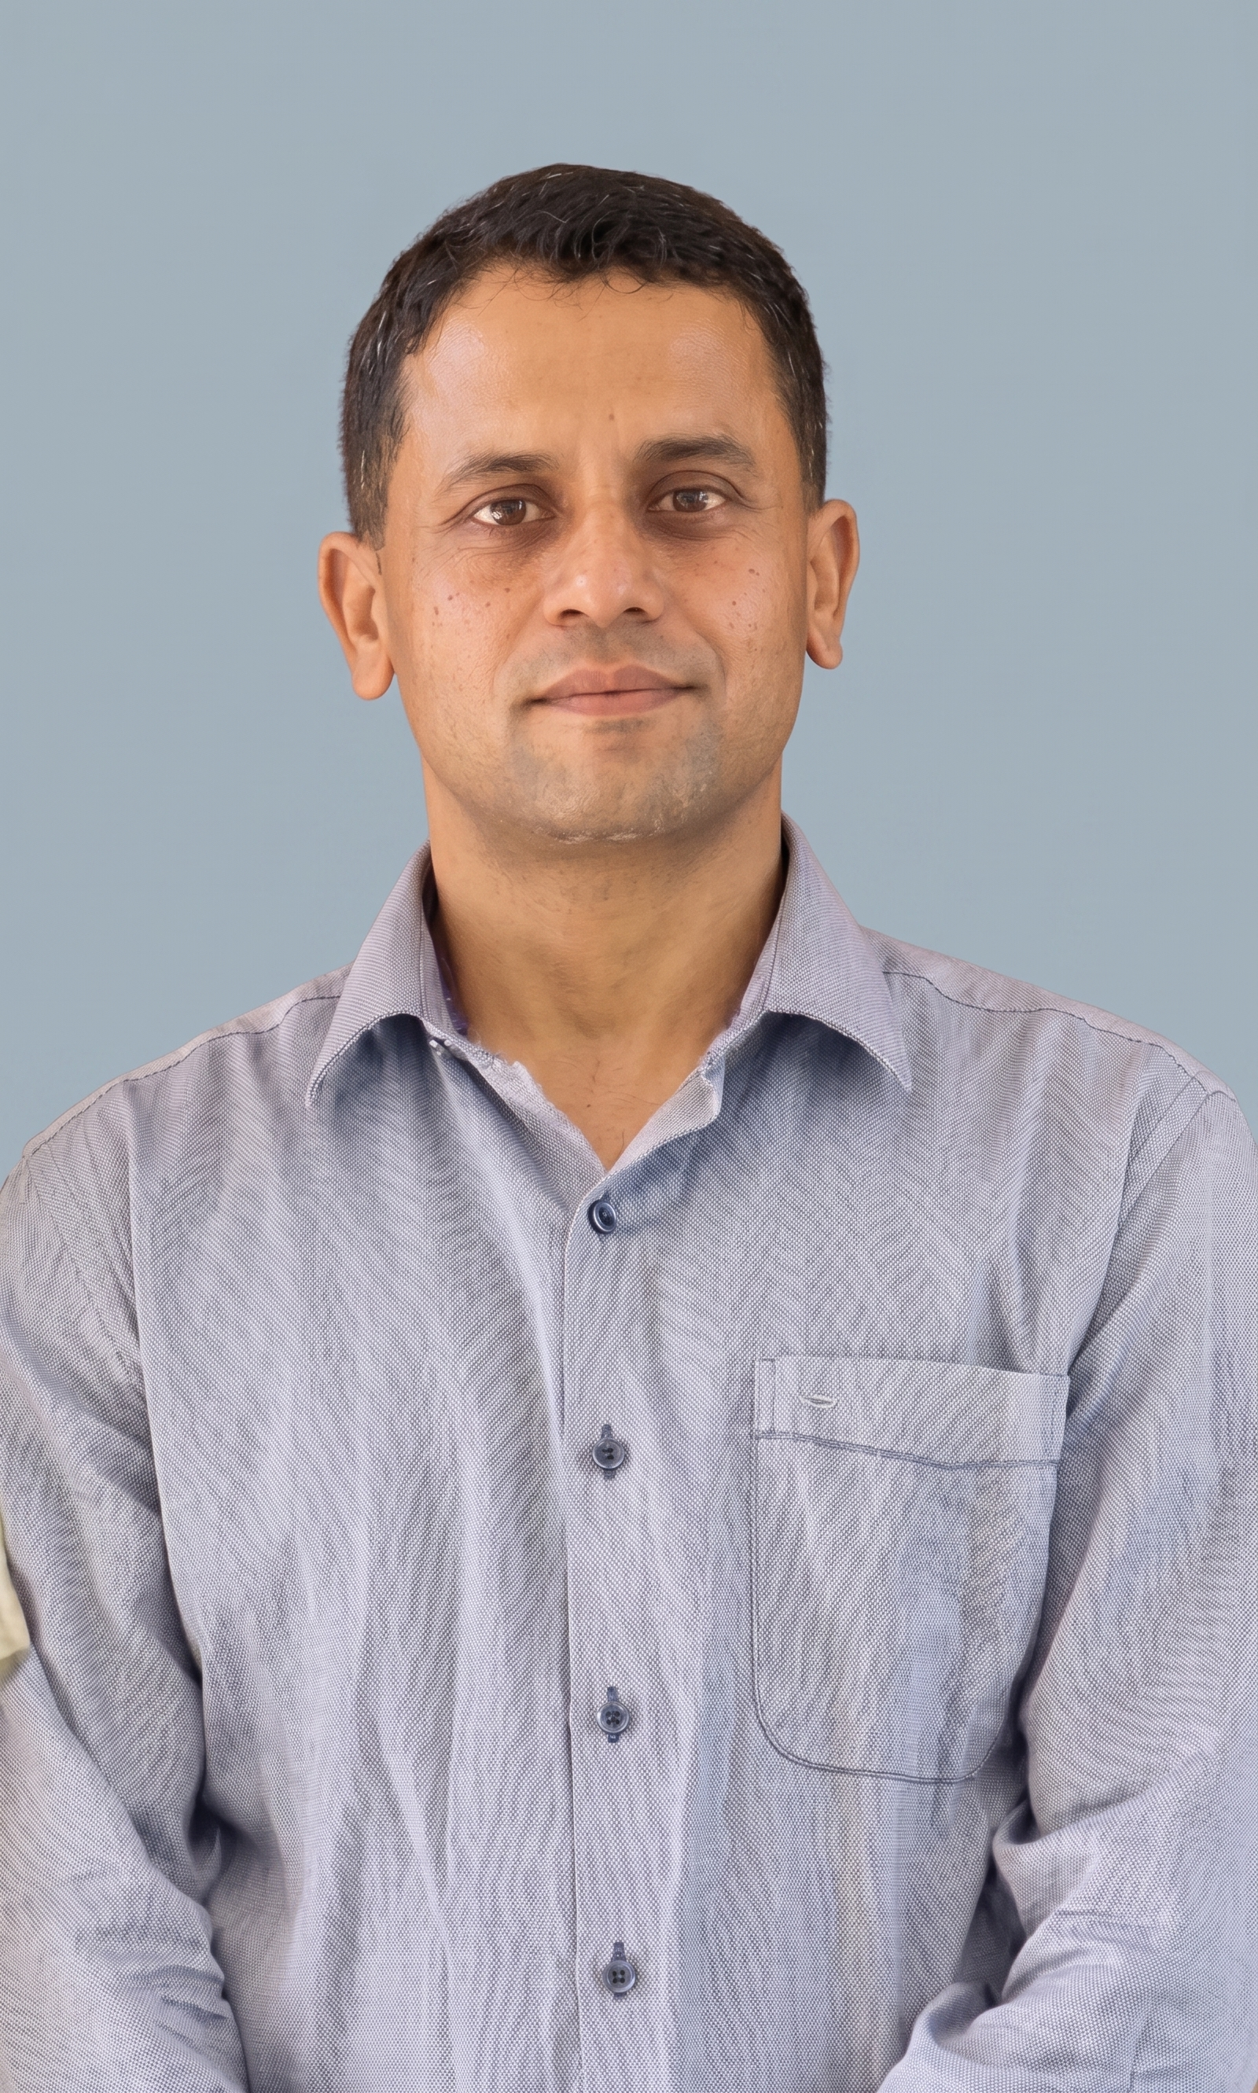
PROFILE SUMMARY
Accomplished physicist and educator with over 17 years of comprehensive teaching experience across secondary and higher education in Uttarakhand, comprising more than 8 years as Assistant Professor in Physics in collegiate education and 9 years at Government Inter College, Kamad (Uttarkashi) under the Uttarakhand Vidhyalayee Shiksha Parishad (UBSE). Specialized in condensed matter physics, ferroelectric phase transitions, and theoretical modeling. Honored with the prestigious Young Scientist Award (2016) by UCOST. Authored 11 peer-reviewed research papers, 3 books/chapters, and presented at 22 national and international conferences.
AREAS OF SPECIALIZATION
Condensed Matter Physics & Crystallography • Hydrogen-Bonded Ferroelectrics & Phase Transitions • Dielectrics & Ultrasonics
Ferrite Materials • Optics & Spectroscopy • Nuclear & Particle Physics • Environmental Geophysics
ACADEMIC QUALIFICATIONS
Degree | Subject / Specialization | Board / University | Division
D.Phil. | Physics (Condensed Matter Physics, Ferrites, Crystallography) | H.N.B. Garhwal Central University, Uttarakhand | Awarded
M.Sc. (PG) | Physics | H.N.B. Garhwal University, Uttarakhand | First Division
B.Ed. | Mathematics & Science Stream | H.N.B. Garhwal University, Uttarakhand | First Division
RESEARCH & PUBLICATION METRICS
• Total Research Papers in Refereed / Peer-Reviewed Journals: 11
– SCI / SCIE-Indexed Journals: 03
– Scopus-Indexed Journals: 04
– Other Refereed / Peer-Reviewed International & National Journals: 07
• Published Books & Authored Chapters: 03
CONFERENCES, SEMINARS & SYMPOSIA
• Total Conferences & Seminars Attended / Papers Presented: 22
– International Conferences: 05 (Including ICRTFM MANIT Bhopal, IPCBEE Chengdu China, and International Academy of Physical Sciences)
– National Seminars & Conferences: 17 (Including Indian Science Congress, National Seminars on Ferroelectrics & Dielectrics, and UCOST Science Congress)
HONORS, AWARDS & PROFESSIONAL EXPERIENCE
• Young Scientist Award (2016): Conferred by the Uttarakhand State Science and Technology Congress (UCOST) for outstanding research on mathematical modeling of ferroelectric crystals.
• Teaching Experience: More than 08 years of active undergraduate teaching and laboratory instruction as Assistant Professor in Physics along with 09 years of teaching experience at the secondary and higher secondary levels under Uttarakhand Vidhyalayee Shiksha Parishad (UBSE).

